INTRODUCTION:
The specific gravity of a substance, designated as G_{s}, is defined as the ratio of the density of that substance to the density of distilled water at a specified temperature. Since it is a ratio, the value of G_{s} does not depend on the system of units used and is a numerical value having no units. In soil mechanics, the specific gravity of soil solids is an important parameter and is a factor in many equations involving weight-volume relationships. Remember that the specific gravity of soil solids refers only to the solid phase of the three phase soil system, it does not include the water and air phases present in the void space. For soil solids, G_{s} may be written as:

OBJECTIVE:
Determine the specific gravity of soil fraction passing 4.75 mm I.S sieve by density bottle.
THEORY:
The specific gravity of soil solids is determined by either (a) density bottle or (b) specific gravity flask or (c) pycnometer. The density bottle is suitable for all types of soil and it is the accrutate method. Whereas the specific gravity flask or pycnometer methods are only suitable for coarse grained soils.

APPRATURS REQUIRED:-
- Density bottle of 50 ml with stopper having capillary hole.
- Balance to weigh the materials (accuracy 10gm).
- Wash bottle with distilled water.
- Alcohol and ether.
- Constant temperature water bath
FIGURES:-
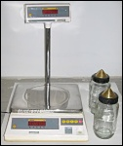
TEST PROCEDURE:-
1. Clean and dry the density bottle
- wash the bottle with water and allow it to drain.
- Wash it with alcohol and drain it to remove water.
- Wash it with ether, to remove alcohol and drain ether.
2. Weigh the empty bottle with stopper (W₁)
3. Take about 10 to 20 gm of oven soil sample which is cooled in a desiccator. Transfer it to the bottle. Find the weight of the bottle and soil (W₂).
4. Put 10ml of distilled water in the bottle to allow the soil to soak completely. Leave it for about 2 hours.
5. Again fill the bottle completely with distilled water put the stopper and keep the bottle under constant temperature water baths (T_{x}⁰ ).
6. Take the bottle outside and wipe it clean and dry note. Now determine the weight of the bottle and the contents (W₃).
7. Now empty the bottle and thoroughly clean it. Fill the bottle with only distilled water and weigh it. Let it be W₄ at temperature (T_{x}⁰ C).
8. Repeat the same process for 2 to 3 times, to take the average reading of it.

CALCULATIONS
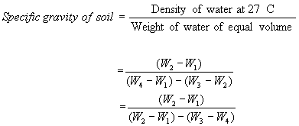
INTERPRETATION AND REPORTING
Unless or otherwise specified specific gravity values reported shall be based on water at 27⁰C. So the specific gravity at 27⁰C = K Sp. gravity at T_{x}⁰C.
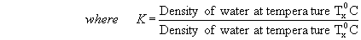
The specific gravity of the soil particles lie with in the range of 2.65 to 2.85. Soils containing organic matter and porous particles may have specific gravity values below 2.0. Soils having heavy substances may have values above 3.0.

Sample Calculation:
Specimen number | 1 | 2
Pycnometer bottle number | 96 | 37
W_{P} = Mass of empty, clean pycnometer (grams) | 37.40 | 54.51
W_{PS}= Mass of empty pycnometer + dry soil (grams) | 63.49 | 74.07
W_{B}= Mass of pycnometer + dry soil + water (grams) | 153.61 | 165.76
W_{A}= Mass of pycnometer + water (grams) | 137.37 | 153.70
Specific gravity (G_{S}) | 2.65 | 2.61
W_{P} = 37.40 g, W_{PS} = 63.49 g, W_{B} = 153.61 g, W_{A} = 137.37
W_{o} = 63.49 – 37.40 = 26.09 g
G_{s} = (26.09) / [26.09 + (137.37 -153.61)] = 2.65

Empty Table:
Specimen number
Pycnometer bottle number
W_{P} = Mass of empty, clean pycnometer (grams)
W_{PS}= Mass of empty pycnometer + dry soil (grams)
W_{B}= Mass of pycnometer + dry soil + water (grams)
W_{A}= Mass of pycnometer + water (grams)
Specific gravity (G_{S})

W_{P} = ____ g, W_{PS} = ____ g, W_{B} = ____ g, W_{A} = ____
W_{o} = ____ g
G_{s} =

REFERENCES:-
- IS : 2720 (Part II) – 1973, Method of Test for soil : Part II
- Soil Mechanics and Foundations.

QUIZ:
- Which method is mostly used to determine the water content in field?
- What is water content for loss soil?
- On which factor cater content is depends?

PART – 2
ANIMATION STEPS

It consists of step wise animation.
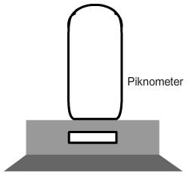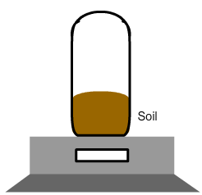

STEP – 1 STEP – 2
Step – 1: Weight of empty pycnometer.
Step – 2: Weight of sample soil with container.

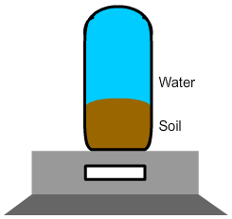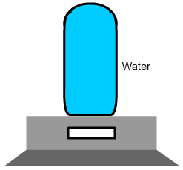
STEP – 3 STEP – 4
Step – 3: Weight with both water and Soil sample.
Step – 4: Weight with full container of water.
PART – 3
VIRTUAL LAB FRAME
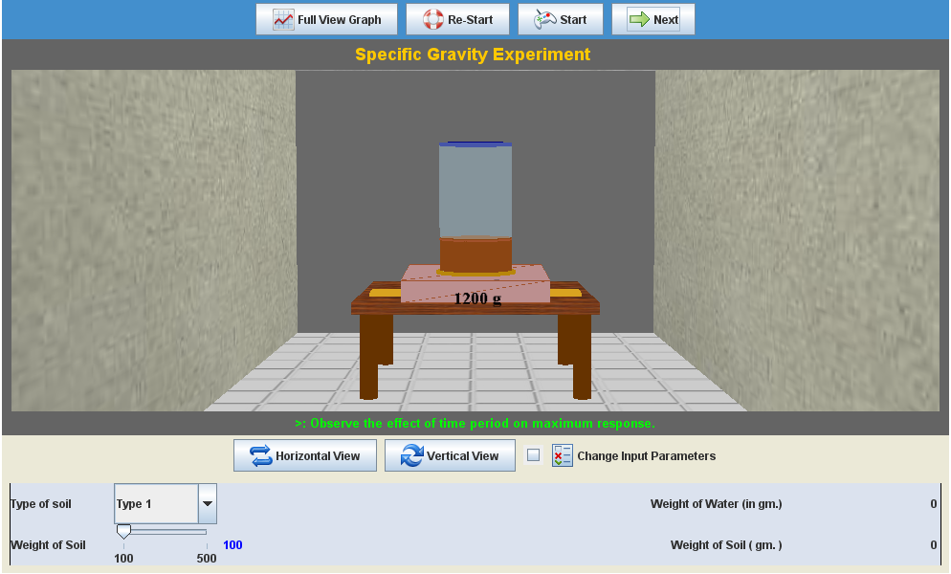
LABORATORY ROOM CONSISTS:
- Table
- Sample Soil
- Pycnometer Heater
- Weight Balance

INPUT:
- Type of Soil
- Weight of Sample Soil

OUTPUT:
- Specific Gravity

